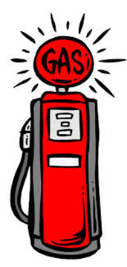
“Fill’er Up!”
As you see the pictures of the gas pump at various times, plot the corresponding numbers on the graph below. Make sure you label the graph correctly.

Use the graph to estimate how much 20 gallons of gas will cost. Plot this point on the coordinate grid.
What is the unit rate of the gasoline?

