Overview of Instructional Task: Percent and Fractional Discounts—Bargain Shopping

This task helps students develop strategies for solving problems involving percents and fractions.

Task should be implemented after students have begun work on percents in *Bits and Pieces III*, but before complete mastery (after Lesson 5.1, April 2–6, 2012).

One to Two Days Before Lesson

* Students work independently on Bargain Shopping task (page 2) (10–15 minutes). Calculators should be available.
* Collect student work.

Analyze responses and write questions on each student paper. Do not score at this time.

Lesson

* Return each student’s Bargain Shopping work with your questions.
* Students work independently revising Bargain Shopping task, guided by your questions (10 minutes).
* Students work in small groups to produce common solutions on a fresh Bargain Shopping task paper   
  (10 minutes).
* Students work with same small groups to analyze flawed student work samples (pages 8–13) (20 minutes).
* Conduct whole class discussion of student work samples (10 minutes), using projector resources (pages 8–14).
* Students individually revisit and revise their original work on Bargain Shopping task (10–15 minutes at end of lesson or during next class).

After Lesson

* Analyze student responses to identify next instructional steps.

Task may be graded if desired (see DPS Rubric, page 15).

Name: Date:

Bargain Shopping

**C:\Documents and Settings\rsauer\Local Settings\Temporary Internet Files\Content.IE5\UMOZ56X1\MC900113476[1].wmf**

The regular price on a pair of jeans is $54.

* The store advertises a back-to-school sale at 40% off the regular price of the jeans.

Two weeks later, the store advertises a sale at an additional $\frac{1}{5}$ off the sale price of   
these jeans.

Two friends decide to purchase the jeans. Shannon says that the jeans are now 60%   
off the regular price. Mary disagrees because she figures that the total discount is actually   
less than 60%.

1. What is the cost of the jeans at the back-to-school sale? Justify your reasoning using a model.
2. What is the cost of the jeans during the additional off sale? How can you show this with a model?
3. Who has figured the discount correctly, Shannon or Mary? Explain your answer using a model.

Instructional Task: Percent and Fractional Discounts—Bargain Shopping

Mathematical Goals

This instructional task helps assess how well students:

* Find percent and fractional discounts.

Use percent and fraction models to solve problems.

Common Core State Standards

This instructional task emphasizes the following Standards for Mathematical Practice:

1. Make sense of problems and persevere in solving them.
2. Reason abstractly and quantitatively.
3. Model with mathematics.

This instructional task also asks students to select and apply mathematical content from the Common Core State Standards.

6.RP.3: Use ratio and rate reasoning to solve real-world and mathematical problems (e.g., by reasoning about tables of equivalent ratios, tape diagrams, double number line diagrams, or equations).

6.RP.3a: Find percents of quantities as a rate per 100; solve problems involving finding the whole, given a part and the percent.

Required Materials

* Copies of task, Bargain Shopping, for students (page 2)
* Copy of task, Bargain Shopping, for each small group (page 2)
* Copies of student work samples for each small group (pages 8–13)
* Calculators, if necessary or requested
* Projector resources to help with whole class discussion (pages 8–14)

Time

Times given are only approximate. Exact timings depend on class needs.

* One to two days before lesson: 10–15 minutes

Lesson: 60 minutes

Before Lesson

Instructional Task: Bargain Shopping (15 minutes)

Have students do this task **in class** a day or more before the instructional task, so you can assess the work, find out the kinds of difficulties students are having, and more effectively focus the follow-up lesson.

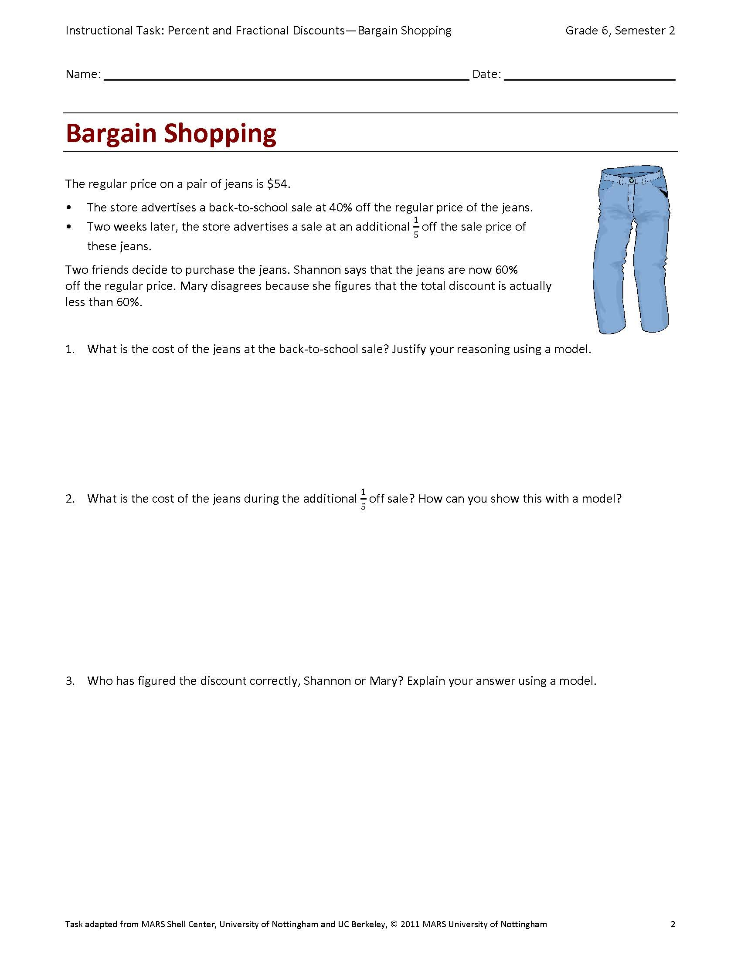Distribute copies of the task,Bargain Shopping (page 2).

Introduce the task briefly and help the class understand the task and   
its context.

Read the questions and try to answer them as carefully as you can. Show all your work so I can understand your reasoning. Use another paper if you need more room. In addition to trying to solve the task, I want to see if you can present your work in an organized and clear manner, so I can understand your thinking. Include a model for each section.

It is important that students answer the questions without assistance, as far as possible.

Students who sit together often produce similar answers, then when they come to compare their work, they have little to discuss. For this reason, you might have students do the task individually and move them to different seats. Then at the beginning of the instructional task session, allow them to return to their usual seats. Experience has shown that it produces more profitable discussions.

Provide Student Feedback

Collect students’ responses to the task. Make some notes on what their work reveals about their current levels of understanding and their different problem-solving approaches.

**Do not score students’ work.** Research shows that it is counterproductive, as it encourages students to compare their scores and distracts their attention from what they can do to improve their mathematics.

Instead, help students to make further progress by summarizing their difficulties as a series of questions, such as the suggestions that follow. Write your questions on your students’ work, using the following ideas. You may also note students with particular issues, so you can monitor their work during the lesson.

| Common Issues | Suggested Questions and Prompts |
| --- | --- |
| Student has difficulty getting started. | What is the task about? What can you tell me about it?  What do you know?  What do you need to find out? |
| Student does not use any models. | How can you model percentages? Fractions?  What is the “whole” in this problem? Into how many parts would you divide the whole? What would be the value of each part? What percent benchmarks could you use?  How could you use your model to answer the questions?  How could you label your model so the connection to the problem situation is clearer? |
| Student finds amount of discount rather than cost  of jeans. | Does you answer make sense?  When you find 40% of $54.00, what information does it give you? Is it the amount you will pay? How can you find the amount you must pay for  the jeans?  What part of your model shows the discount? What part shows the sale price? |
| Student works unsystematically. | Can you organize your work in a systematic way?  Have you labeled your answers and made clear what you calculated?  Have you shown how your models connect to the problem? |
| Student presents work poorly. | Have you explained how you arrived at your answer?  Would someone else easily understand your work?  Would labels or diagrams help make your process clearer? |
| Student produces correct solution.  Student needs extension task. | The final price of the jeans is what percent off  the original price?  Suppose you decide to buy a shirt that is also  on sale for 40% off the original price plus an additional 1/5 off the sale price. The final price  of the shirt is now $34.56. What was the original price of the shirt? |

Suggested Lesson Outline

Improve Individual Solutions to Instructional Task (10 minutes)

Return students’ instructional task papers.

Recall what we looked at previously. What was the task? I have read your solutions, and I have some questions about your work. I would like you to work on your own to answer my questions for about  
ten minutes.

Small Group Collaborative Work (10 minutes)

Organize the class into small groups of two or three students and distribute a blank Bargain Shopping task   
(page 2) to each group. Ask students to try the task again; this time combining their ideas.

Put your own work aside until later in the lesson. I want you to work in groups now. Your task is to produce a solution that is better than your individual solutions.

While students work in small groups, note different student approaches to the task and support student problem solving.

Note Different Student Approaches to Task

Use this information to focus a whole class discussion towards the end of the lesson. In particular, note any common mistakes.

Support Student Problem Solving

Try not to make suggestions that move students towards a particular approach to this task. Instead, ask questions that help students to clarify their thinking. To help students really struggling with the task, use the questions on the previous page to support your questioning.

If the whole class struggles with the same issue, write relevant questions on the board. You could also ask students who performed well on the task to help struggling students. If students are having difficulty making any progress at all, hand out the student work samples (pages 8–13) to model problem-solving methods.

Collaborative Analysis of Student Work Samples (20 minutes)

After students have had sufficient time to attempt the task, give each small group of students copies of the student work samples (pages 8–13) and ask for written comments. This step gives students the opportunity to evaluate a variety of possible approaches to the task, without providing a complete solution strategy.

Imagine you are the teacher and have to assess this work. Correct the work and write comments on the accuracy and organization of each response.

Each student work sample poses specific questions for students to answer. In addition to these questions, you could ask students to evaluate and compare responses. To help them do more than check if the answer is correct, you may want to ask the following questions (page 14).

* How did this student organize his or her work?
* What mistakes have been made?

What misconceptions do you think this student has?

* What isn’t clear?
* What questions would you like to ask this student?
* In what ways might the work be improved?

Every group may not have enough time to work through all student work sample questions. If so, be selective about what you hand out.

During small group work, support students as before. Note similarities and differences between students’ approaches during small group work and student work sample approaches. Also check which methods students have difficulties understanding to focus the next activity, a whole class discussion.

Whole Class Discussion: Compare Different Approaches (10 minutes)

Organize a whole class discussion to consider different approaches used in the student work samples (pages 8–13). Focus the discussion on those parts of the small group tasks that students found difficult. Ask students to compare different solution methods.

Which approach did you like best? Why?

Which approach did you find most difficult to understand? Why?

What different ways did students model the task? Did the models help you understand and solve the task?

Individually Review Original Solutions to Task (10 minutes)

Ask students to revise their original responses to the task (provide paper as needed).

Read your original solutions and think about your work on this task. Using what you learned, revise your original individual solutions.

Solutions

1. $32.40 with a model
2. $25.92 with a model
3. Mary is correct (supported with a model).

Sample 1: Amy

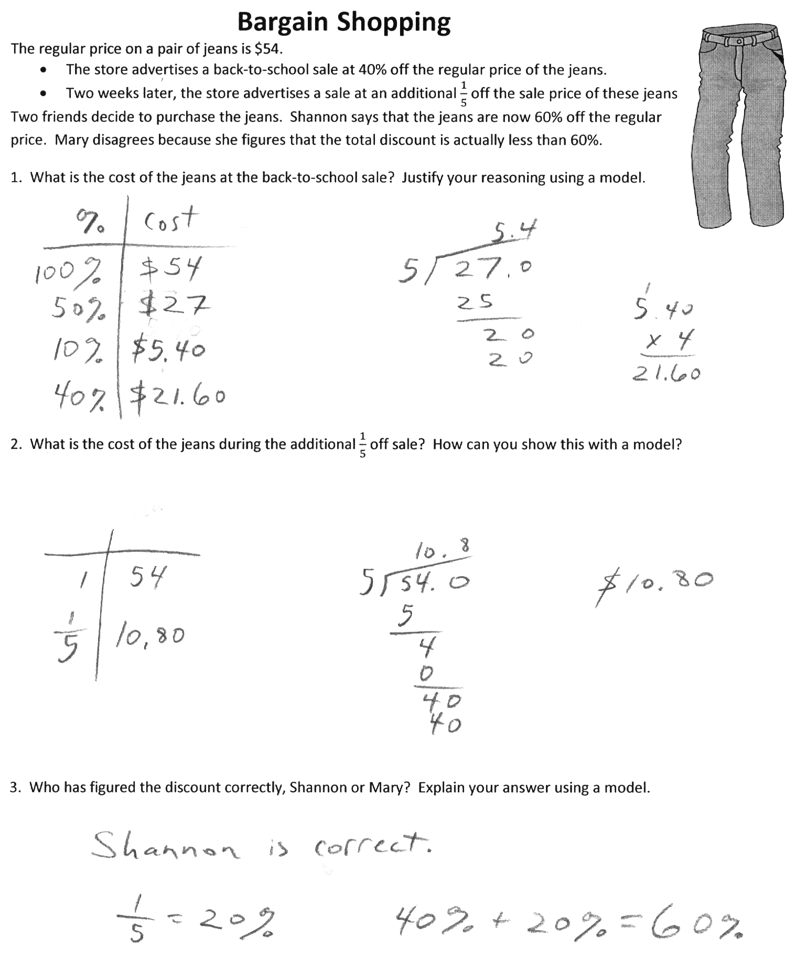

In question 1, what method did Amy use to find the cost of the Jeans? Why did she divide 27 by 5 to get 5.4?   
How did she get $21.60? Is this the cost of the jeans?

In question 2, how did Amy find 1/5? Is this the cost of the jeans? What is $10.80 in this problem?

Are the equations Amy wrote in question 3 correct? Does this mean that Shannon is correct?

Did Amy justify her reasoning? Did she justify her reasoning with a model?

Sample 2: Bill



1. What is the cost of the jeans at the back-to-school sale? Justify your reasoning using a model.  
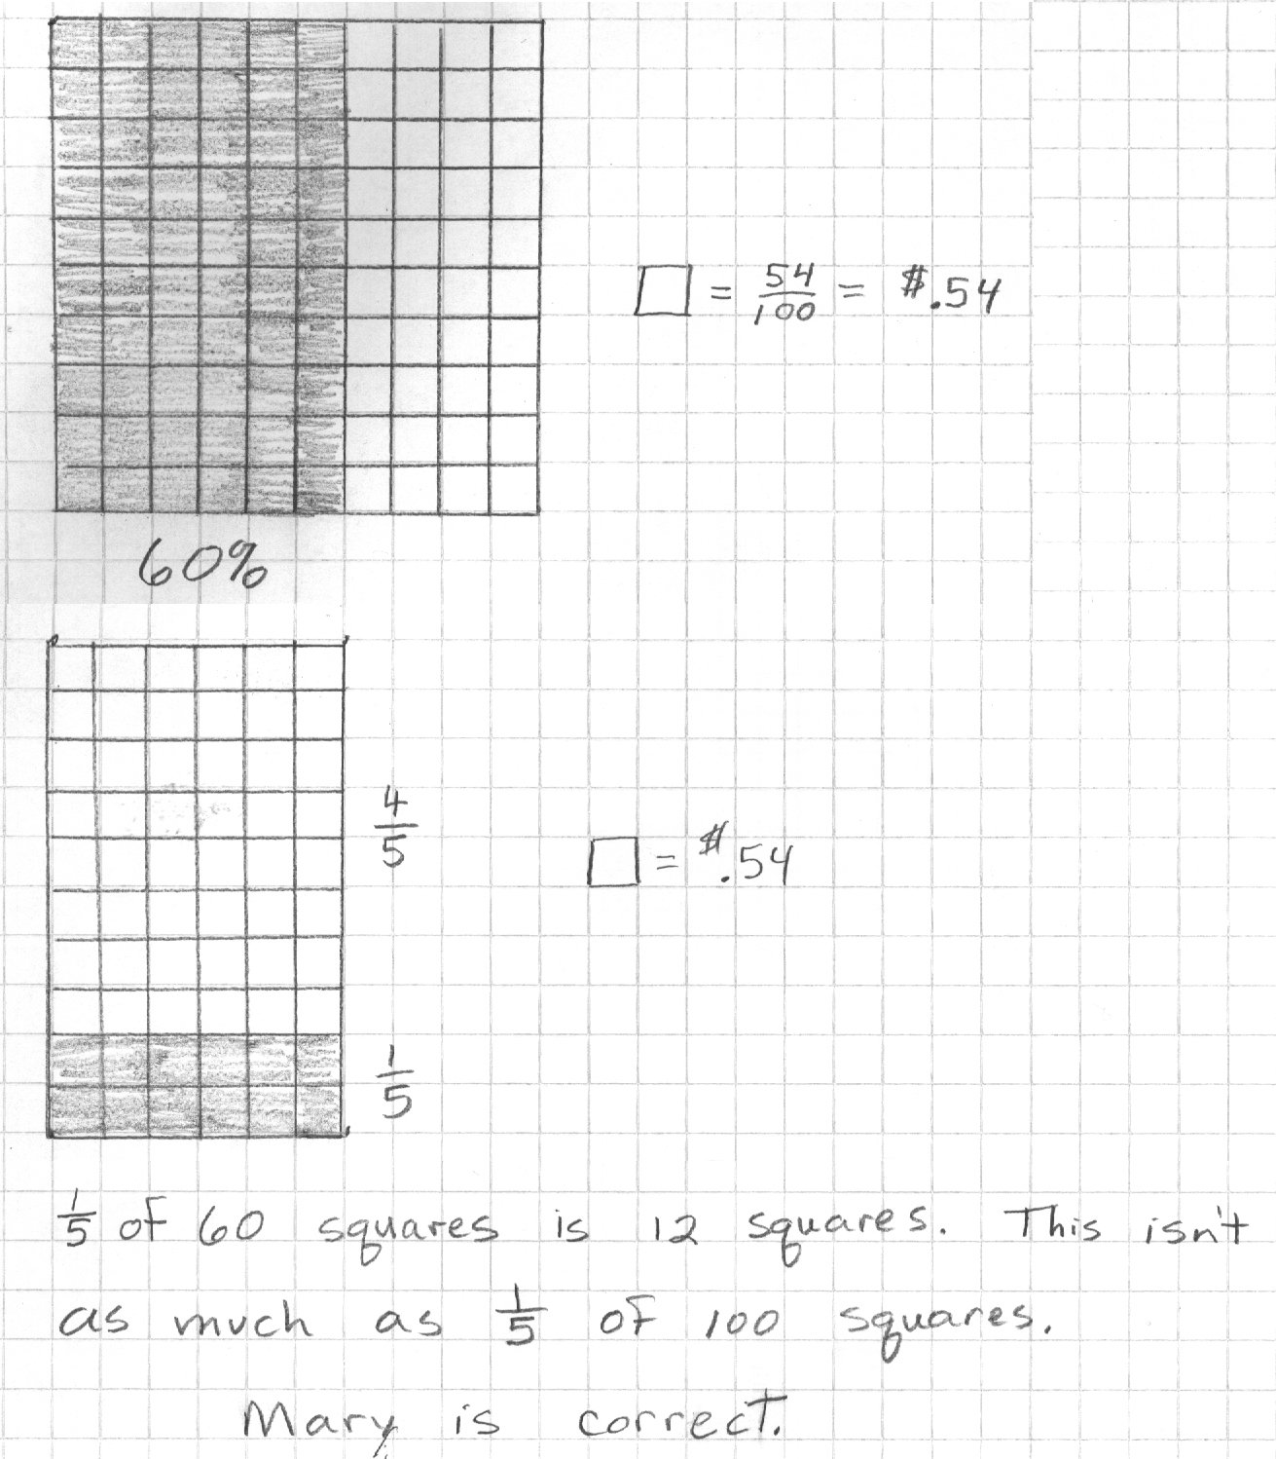

2. What is the cost of the jeans during the additional off sale? How can you show this with a model?  


3. Who has figured the discount correctly, Shannon or Mary? Explain your answer using a model.  


Look at Bill’s model for question 1. Why did Bill shade 60%?

In question 1, why does Bill write 🞏 = = $.54? Why did he divide by 100? How will it help him solve the problem? Has Bill answered the question?

Does Bill use a diagram with 100 squares in question 2? Why not? Why does he shade 12 squares?

How can Bill use his diagram in question 2 to answer the question?

How does Bill’s explanation to question 3 support his answer that Mary is correct? Is it easy to understand what he means? How could he make his thinking clearer?

Sample 3: Carmen

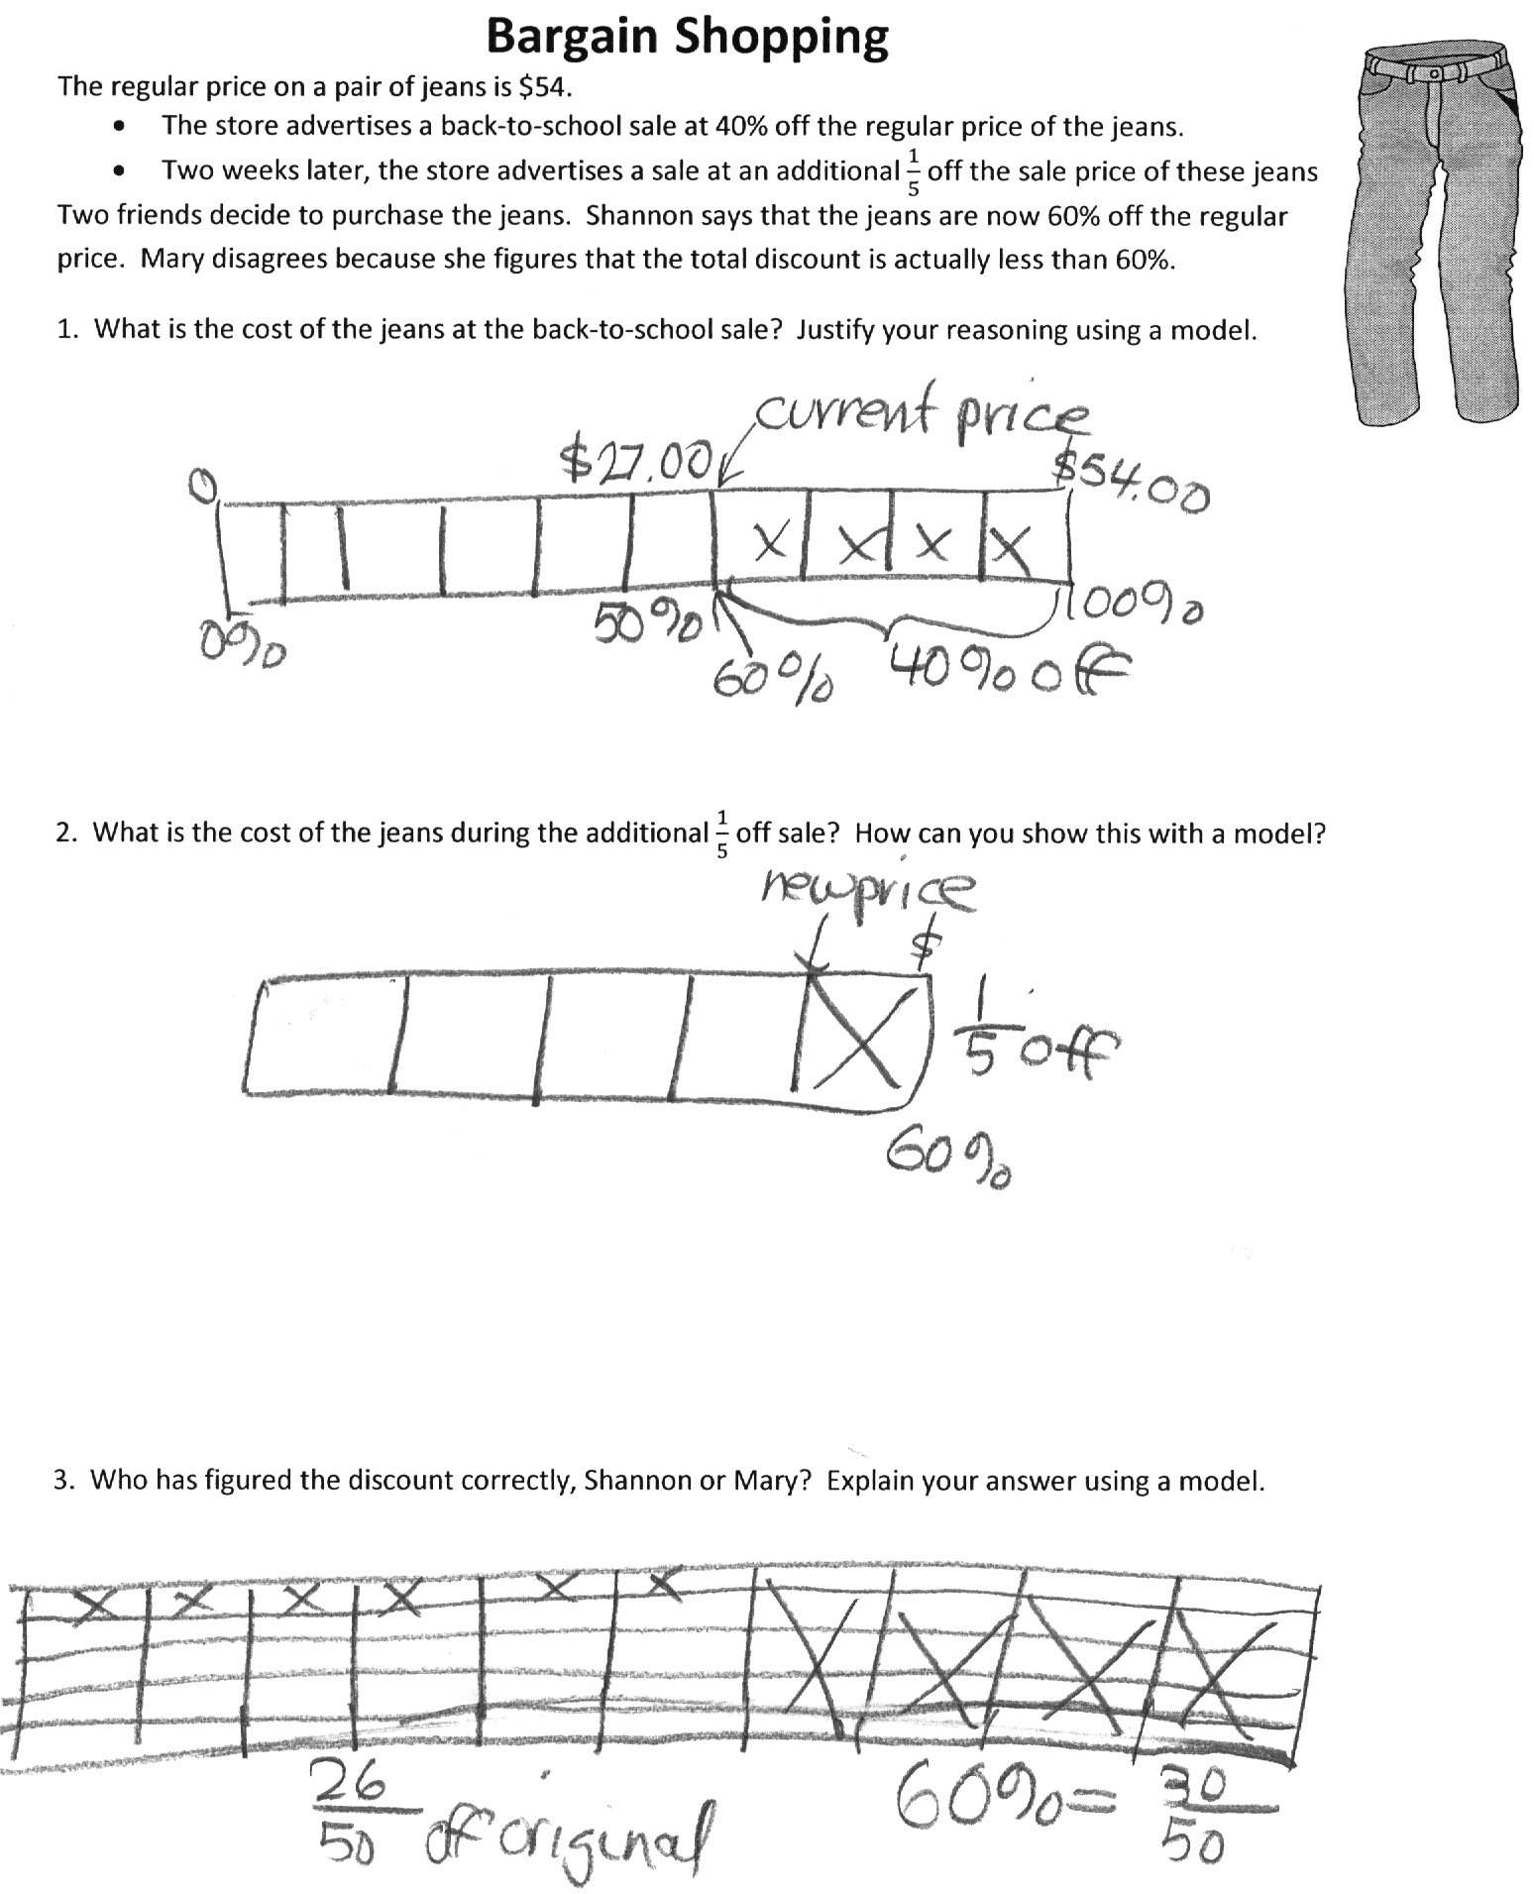

Look at Carmen’s model for question 1. Why do you think she divided into 10 parts? Is 50% marked in the correct place? Is 60%? How do you know?

In question 1, Carmen shows the current price at more than $27.00. Do you agree? How could she use her diagram to help find the exact price?

Look at Carmen’s diagram for question 2. Can you understand her thinking? How could she use the diagram   
to find the new price?

Look at Carmen’s diagram for question 3. Can you understand her thinking? Does her work show that Mary or Shannon is correct? How could she make her thinking clearer?

*Evaluating Student Work Samples*

* *How did this student organize his or her work?*
* *What mistakes have been made?*
* *What misconceptions do you think this student has?*
* *What isn’t clear?*
* *What questions would you like to ask this student?*

*In what ways might the work be improved?*

