

**My WAVE Observations**

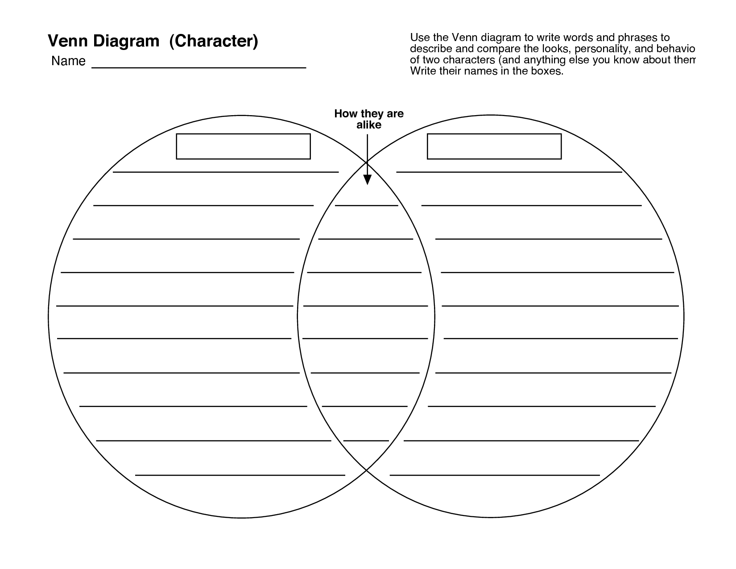

**TRANSVERSE**

**LONGITUDINAL**

COMPARING TRANVERSE AND LONGITUDINAL WAVES

**Showing what I know:**