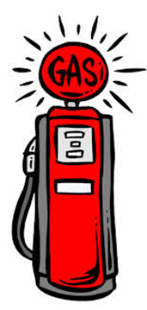
“Fill’er Up!”
As you see the pictures of the gas pump at various times, plot the corresponding numbers on the graph below. Make sure you label the graph correctly.

What is the constant rate of change of the gasoline? What does this represent?
Write a linear equation to represent the graph.

