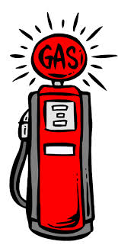
“Fill’er Up!”

As you see the pictures of the gas pump at various times, plot the corresponding numbers on the double number line below.
COST
GALLONS OF GAS

Using the double number lines, plot how much would 20 gallons of gas cost?

Estimate how much the total amount of gas cost. (17.148 g)

